[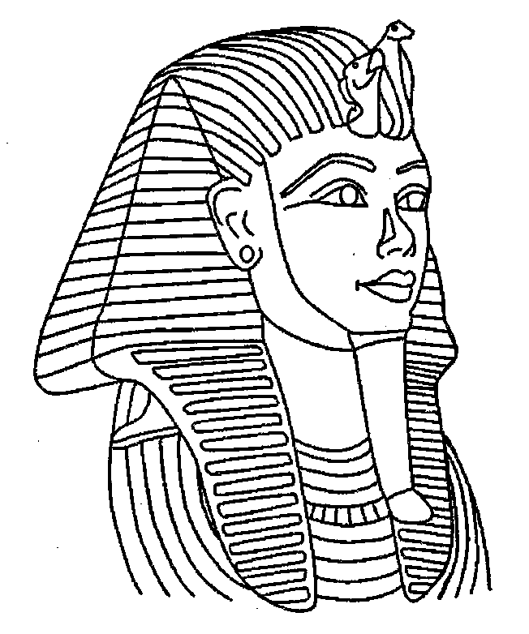](http://www.google.com/url?sa=i&rct=j&q=&esrc=s&frm=1&source=images&cd=&cad=rja&docid=4x4XbJ0FPntWDM&tbnid=_5tt3es4NeFNnM:&ved=0CAUQjRw&url=http%3A%2F%2Fwww.coloringpages1001.com%2Fcoloring-pages%2Fegypt%2F&ei=7PpmUsnGE5K44AOE3oDIDw&psig=AFQjCNHA4LzlwcpOwLxmdnuRK3u1Nvmw-Q&ust=1382567016252242)**ANCIENT EGYPT AND CHINA**

[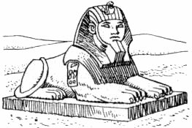](http://www.google.com/url?sa=i&rct=j&q=&esrc=s&frm=1&source=images&cd=&cad=rja&docid=ONLCkWHw-OFiUM&tbnid=Z5S0wtUOfw94VM:&ved=0CAUQjRw&url=http%3A%2F%2Fwww.clipartpal.com%2Fclipart_pd%2Freligion%2Freligion1.html&ei=fPtmUt3fA_K34AOpjoDoAg&psig=AFQjCNE6252AXrZ_IbvDXztV6-2fA8FeCQ&ust=1382567161112568)

[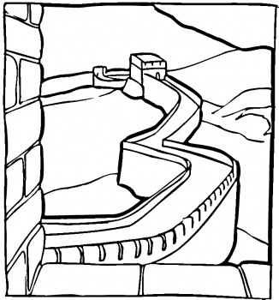](http://www.google.com/url?sa=i&rct=j&q=&esrc=s&frm=1&source=images&cd=&cad=rja&docid=VA8hxMZSQ9nxQM&tbnid=twbYMWii_Pv6bM:&ved=0CAUQjRw&url=http%3A%2F%2Fwww.supercoloring.com%2Fpages%2Fgreat-chinese-wall%2F&ei=rPtmUtTHJ7Lh4AO25IDgCw&psig=AFQjCNHCSK5PWWrXzYVYHj1U8G2bIvgv-w&ust=1382567203443719)

[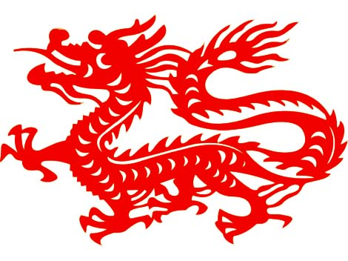](http://www.google.com/url?sa=i&rct=j&q=&esrc=s&frm=1&source=images&cd=&cad=rja&docid=toWiv486CVaTVM&tbnid=2cZWF2tz-pYfNM:&ved=0CAUQjRw&url=http%3A%2F%2Fhome.moravian.edu%2Fstudents%2Fh%2Fstjth05%2Fedlinks.html&ei=9ftmUt_1AvK14AO9yoGYBw&psig=AFQjCNF6K1GYQSvcPAxJN2LqYOp4-FH0vw&ust=1382567264460440)