- What are resources?_____________________________________
- What is a piece of land surrounded by water on 3 sides called? _____________________________
- The land of Ancient Greece had limited ___________________________ because of the many _______________________________________.
- What body of water surrounds Greece ________________________________________________________.
- Ancient Greece was surrounded by water. The sea is an example of a ____________________ resource.
- One contribution that Greece made was its architecture. They used ____________________ and ____________________ in the construction of their buildings.

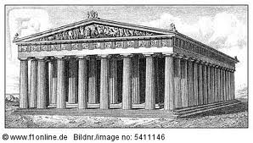
What is the name of this
important building in Greece?

_____________________________________________

- How did the people of Ancient Greece get the resources they could not get themselves? __________________________
- What were the jobs that people in Ancient Greece did to help them survive?
A.
B.
C.
D.
17. What did the Ancient Greeks contribute in terms of sports today? ______________________________________________________
10. The farmers of Ancient Greece used the________________________________ in order to plant their crops.
11. Greece is known as the ___________________________ of Democracy.
12. Democracy means _____________________________________________________________.
13. What is it called when people focus on the production of certain goods and services? __________________________________
14. What does it mean when I say that Greece was interdependent on others? ___________________________________
______________________________________________________________
15. What is one example of a good that the people of Ancient Greece would have used or sold?_____________________________
16. What is one example of a service that the people of Ancient Greece could have provided? ________________________________
18. Who decided what would be discussed at each Assembly Meeting? _______________________________________________
19. What type of democracy did Greece use that allowed the people to be in control of the laws through voting, rather than having a representative? ____________________________________
20. What types of art did the Ancient Greeks contribute to us?
____________________________________________________________________________________________________________________________

