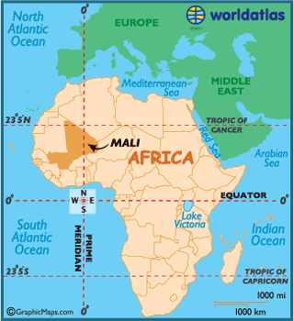
Ancient Mali Notes

Name_______________________________
Important Vocabulary

- Characteristics: Different Traits
- Human Characteristics: things people do for a living (jobs) in a particular place
- Physical Characteristics: how the land or area looks for a specific place
- Specialization: focusing on one product or service
- Interdependence- two or more people depending on each other for goods and services.
- Natural Resource: materials that come directly from nature
- Human Resource: people working to produce goods and services
- Capital resource: goods made by people and used to produce OTHER goods or provide services.

Physical Characteristics
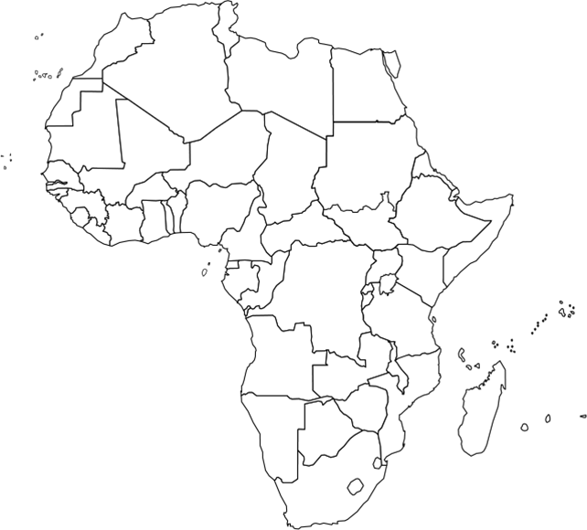

Africa was home to several great empires. One of the most prosperous was the early West African empire of ________________. Mali is a ________________ and Africa is a ___________________________________.
Physical Characteristics
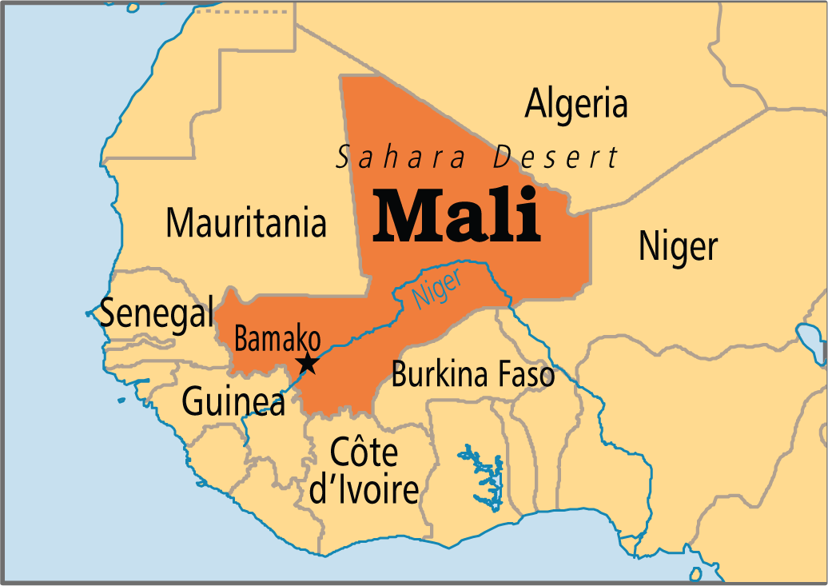

Mali is located near the Niger ______________. Most of Mali is a hot, sandy, rocky ___________________. It is near the _______________ Desert. It also has grasslands. Mali is considered landlocked because it does not touch an __________________. Mali was home to many _____________ mines.
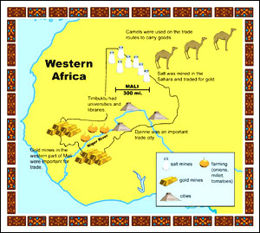
Trade

For the people of the desert, ______________ was a valuable resource. People used this for their ________________ and for preserving _____________. Miners found ___________ in Western Africa.
Mali lay across the trade __________ between the sources of salt in the ________________________________ and the gold ____________ of West Africa.

__________ was traded for ___________.
Human Characteristics

_________________________

__________________________

___________________________

_____________ were oral
storytellers who passed
traditions and stories from one
generation to the next.
Ways the People of Mali Adapted

- Salt was an important natural resource needed in Mali.
- Gold from Mali was traded for salt.

Resources
Human Resource- gold miners
Capital Resource- tools to mine
Natural Resource- gold
Mali’s ___________________________ was in gold mining.

Timbuktu
Timbuktu was an important __________ in Mali. It had a famous university with a large ________________ containing Greek and Roman books.
Government
Early Mali was a wealthy trading empire _________________ Columbus sailed to America. Mali was ruled by rich and powerful ________________. The kings controlled all of the ________________. It became one of the largest and wealthiest empires in the region.

___________________ was the first king of Mali. He was a follower of Islam. He was referred to as the long king.

_________________ ______________ was another great king. He was the grandson of Sundiata. He made a _______ to Mecca and made Timbuktu a center for worship and learning.
Architecture
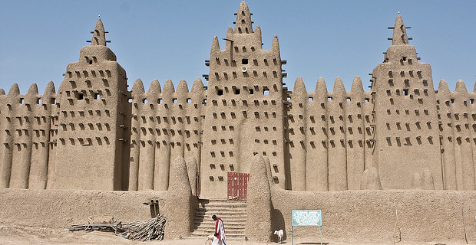

The buildings in Mali were made of ___________ because they didn’t have much wood. The churches in Mali were called mosques. They were also made of mud. During the rainy seasons, several extra layers of mud are added.
Contributions of the Empire of Mali
Storytelling
- Passed on traditions
- Stories told from one generation to the next
- Rich, powerful kings controlled trade in West Africa
- Important Trade Center
- Miners found gold and traded for salt
- People used salt for health and preserving foods
- Protecting empire
- Growing food for empire
- Mining gold
- Traded gold for salt with other people
- Located in West Africa
- Near rivers
- Desert Conditions
- Gold mines
- Farmers
- Miners
- Traders
- Salt was an important natural resource for people in the desert
- Used gold to trade for salt

