Name_____________________________________________
What I want to know about Greece
What I know about Greece

What I learned about Greece

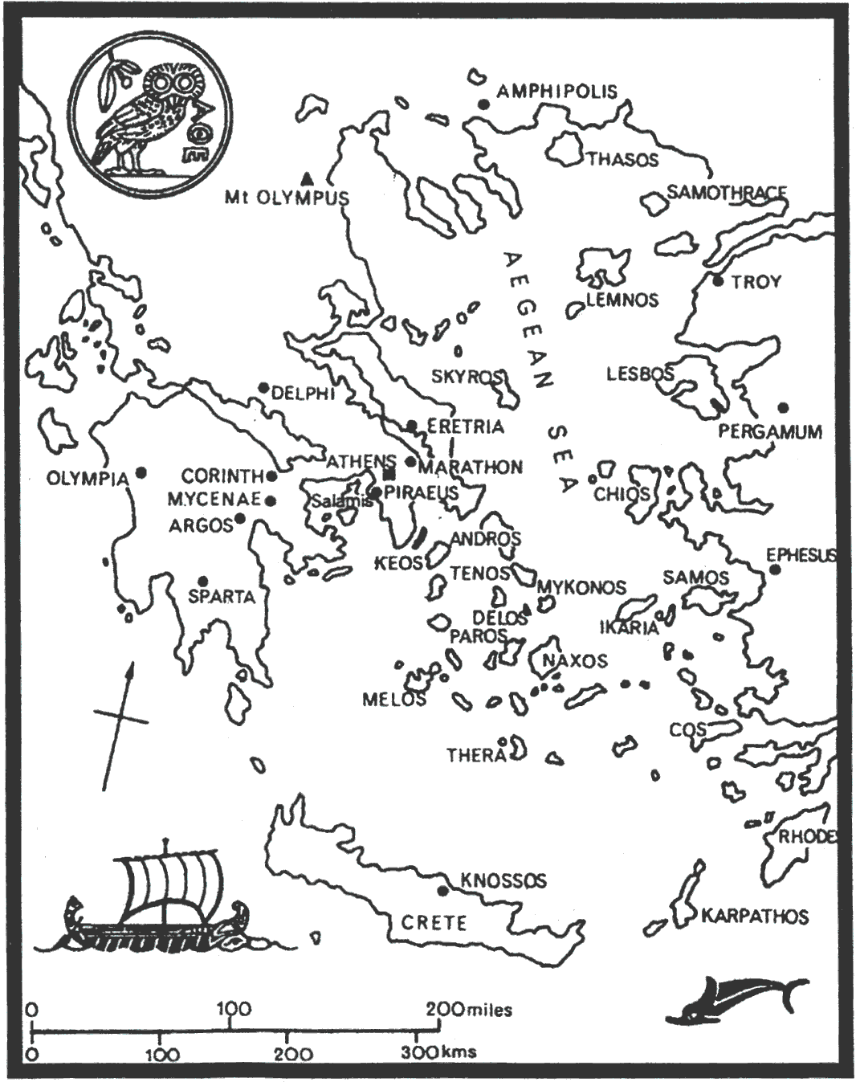
MAP OF ANCIENT GREECE

Ancient Greece was located on a _______________ with many islands, ________________, and hills. It was surrounded by the Mediterranean Sea and had limited ______________.

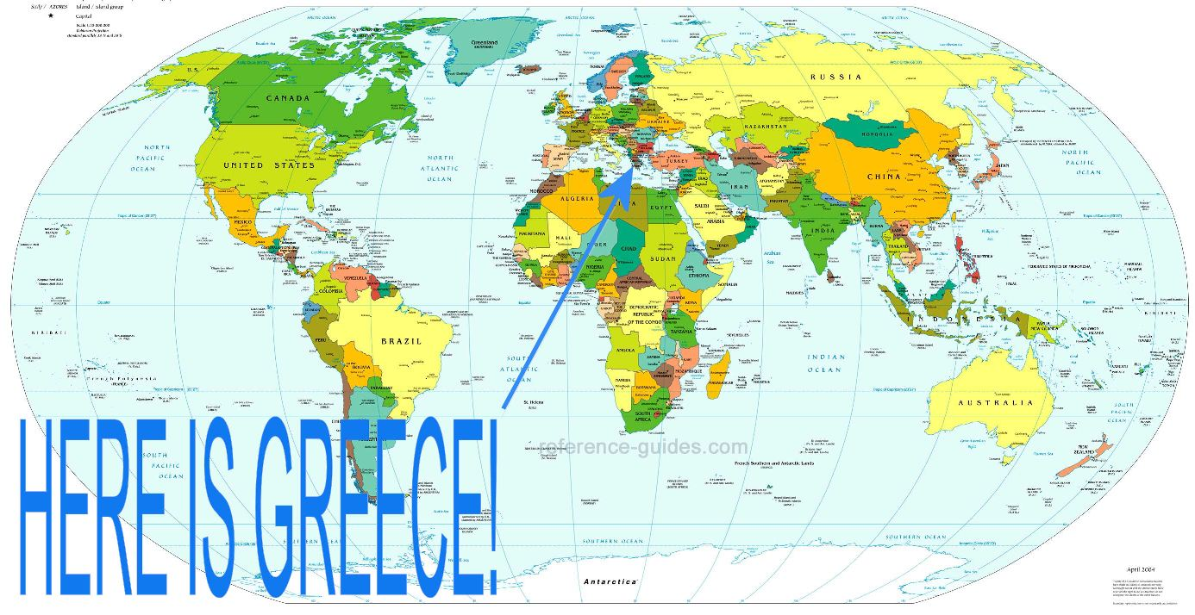

Many people in Ancient Greece survived by being ___________________. They used the large _________________ to do this. Others were _______________________and some were even _________________. The trading in Ancient Greece took place on the _________________________ Sea. The mountains caused small, independent communities to develop.

People and regions often __________________ in the production of certain goods and services. _____________________________ occurs when people focus on the production of selected goods and services.
How the Ancient Greeks Survived

The Greeks did not have all of the resources they needed so they traded with others. They were interdependent on others.
What is something that you are interdependent on?
What is something that you specialize in?

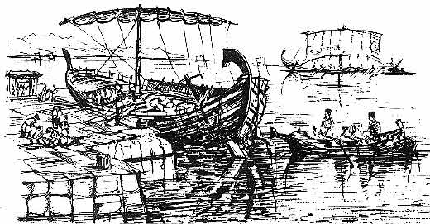
Resources are used to produce __________ and _________________. _____________________ of goods and services are influenced by natural, human, and capital resources. Ancient Greece had access to the sea, which is a _____________ _________________. They used their human and capital resources to produce __________ or __________, which they used for transportation (a ________________)in trading.

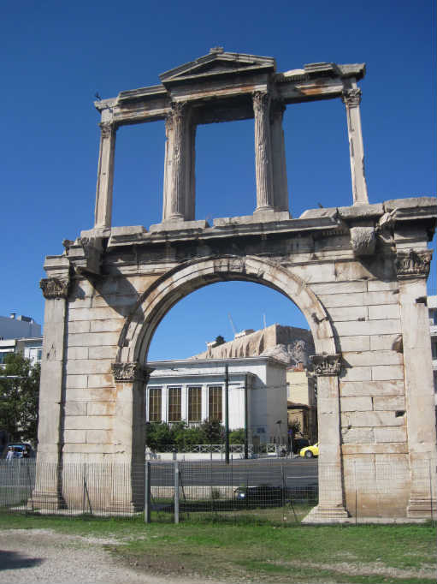
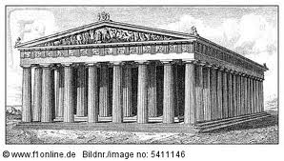

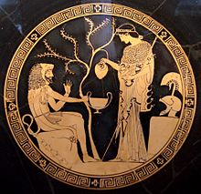
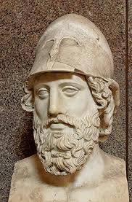
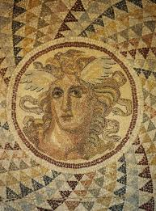

Contributions of Ancient Greece

ARCHITECTURE
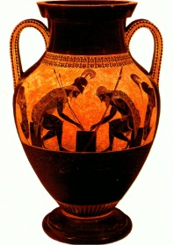
The architects of Ancient Greece used ____________________ and _________________ in the construction of their buildings. Some examples still exist today.

THE ARTS
You will often see _________________, ____________________, and __________________ displayed on buildings.
SPORTS
The ________________ ______________ of today are modeled after the games of Ancient Greece.

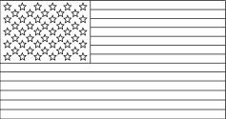
GOVERNMENT
Contributions of Ancient Greece

The government of the United States of America is based on some of the ideas developed in Ancient Greece.

Greece is known as the _____________ ______________ ______ _______________________. This means government by the ________________.

Thousands of male citizens would meet at an ________________ meeting. The Council of ________ decided what would be discussed. Each person had the right to speak and then citizens would vote on the laws.

This is called a _____________ _______________________. People vote to make their own rules and laws.

