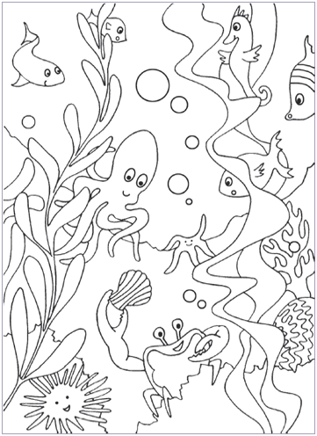
Aquatic Ecosystems and Habitats

Name ________________________

Important Vocabulary
- Ecosystem- all of the living AND nonliving things in an environment and all their interactions
- Community- all of the living things in an ecosystem
- Population- all of the member of a single type of organism
- Habitat- the place where a plant or animal lives
- Aquatic Ecosystem- A system of plants and animals and the interactions between them, that is found in water.
- Saltwater- water in the ocean
- Freshwater- the water in most rivers, streams, creeks, ponds, and lakes
- Conservation- saving a resource or a particular plant or animal from extinction

Fresh Water Habitats

___________________, _____________________, and ____________ have very saturated and water logged land.

________________ are smaller and are a closed in area of water. It is home to many frogs, turtles, fish, and more.

_____________ are a larger area of water with many fish and several other kinds of life.

SOME FRESHWATER HABITATS FLOW
Steams, creeks, and rivers

ECOSYSTEM COMMUNITY

POPULATION HABITAT

SALTWATER HABITAT: OCEAN
- Ocean’s cover ________ percent of Earth’s surface.
- Ocean water is saltwater.
- There are _____ main oceans: Pacific, Atlantic, Arctic, Indian, and Southern.
- The Pacific Ocean is the __________________.
- There are mountains, volcanoes, and deep trenches in the ocean.
- The ocean _______________ cycle twice a day, high and low tide. This has to do with the gravitational pull of the ______________.
- The blue _________ is the largest animal on the Earth.
- The _________________________ is the fastest fish in the ocean.
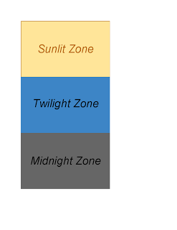
- The ocean has ______ main levels or zones: sunlight (or sunlit), twilight, and midnight zones.

