Rainforest Study Guide- Test Thursday October 17th
- An Ecosystem is all of the living and non-living things in an environment.
- A community is all of the living things in an environment.
- A population is all the members of a single type of organism.
- A habitat is the place where a plant or animal lives.
- When a plant or animal live on land, it lives in a terrestrial ecosystem.
- There are 4 basic needs: food, air, water, shelter

- We must be careful to conserve (save) our limited resources. We must recycle, reduce, and reuse.
- If humans cut down a tree in the forest, they should plant another one in its place.
  - Many animals depend on trees for shelter, food, and oxygen.
- Rainforests are very warm and wet forests. Tropical Rainforests are located near the Equator.
- Tropical Rainforests cover about 7% of the Earth’s surface.
- The largest tropical rainforest is located in the continent of South America. It is called the Amazon Rainforest.
- Rainforests get at least 80 inches of rain a year.
- The average temperature in the rainforest is 75-80 degrees Fahrenheit.
- Trees in the rainforest take in carbon dioxide and produce oxygen.

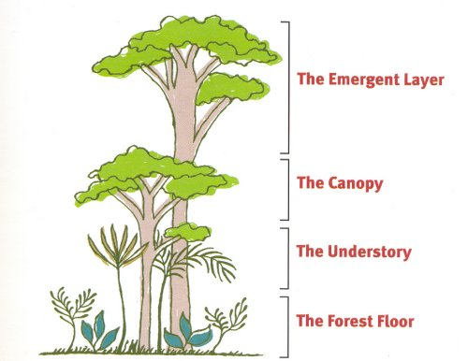
- There are 4 layers in the rainforest: Emergent,
Canopy, Understory, and Forest Floor.
(Be able to label these)
- The Emergent Layer is home to birds (Toucans &
Macaws), Hawks, opossums, butterflies, etc.
- This layer gets the most sunlight.
- The Canopy Layer is home to sloths, monkeys,
apes, snakes, etc.
- There is a lot of plant life here, such as
nuts, berries, and fruits. It is considered
big green umbrella because it shields the
animals from the heat and rain.

- The Understory Layer is home to jaguars, cats, rats, etc.
- There are some plants here, but it does not get as much sunlight because of the shade from the canopy.
- The Forest Floor is home to many bugs, insects, and decomposers (such as mushrooms). The largest animals will roam here.
- Plants in the rainforest adapt or change so that they can survive in the environment.
- Roots are shallow so that they can soak up nutrients from the thin soil.
- Leaves have a waxy surface and pointed tips so that rain will run off easily.
- Some animals like the Harpy Eagle are on the endangered animal list because there are not many of them left and they need to be protected.

Review Information to Know
- Some animals in the rainforest blend in to their environment. This is called camouflage.
- Some animals look like other animals so that they can avoid being eaten by predators. This is called mimicry.
- Some animals move from one place to another when the season’s change. This is called migration.
- Behavioral adaptations- how a plant or animal acts that helps it survive (hibernation, migration, etc.)
- Physical adaptations- how a plant of animal looks that helps it survive (camouflage, mimicry, etc.)
- Carnivores eat only meat. Herbivores eat only plants. Omnivores eat both meat & plants.

