Habitats: Rainforests
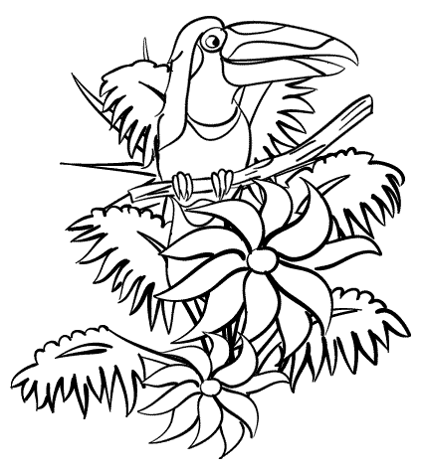

Name_____________________________________________
Important Vocabulary
- Ecosystem- all of the living AND nonliving things in an environment and all their interactions
- Community- all of the living things in an ecosystem
- Population- all of the member of a single type of organism
- Habitat- the place where a plant or animal lives
- Terrestrial ecosystem- A system of plants and animals and the interactions between them, that is found on the land
- Basic Needs: food, air, water, shelter
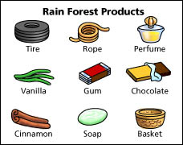

We gets many products and ingredients from the
rainforest. We must work to conserve the
environment by making good choices. We must
be careful to conserve limited resources.

Facts about Rainforests
- They are dense, warm and ___________ forests.
- Over _______ of the world’s plants and animals live in the rainforest.
- There are _____ layers: Emergent, Canopy, Understory, and Forest Floor
- ________________ rainforests are found around the equator
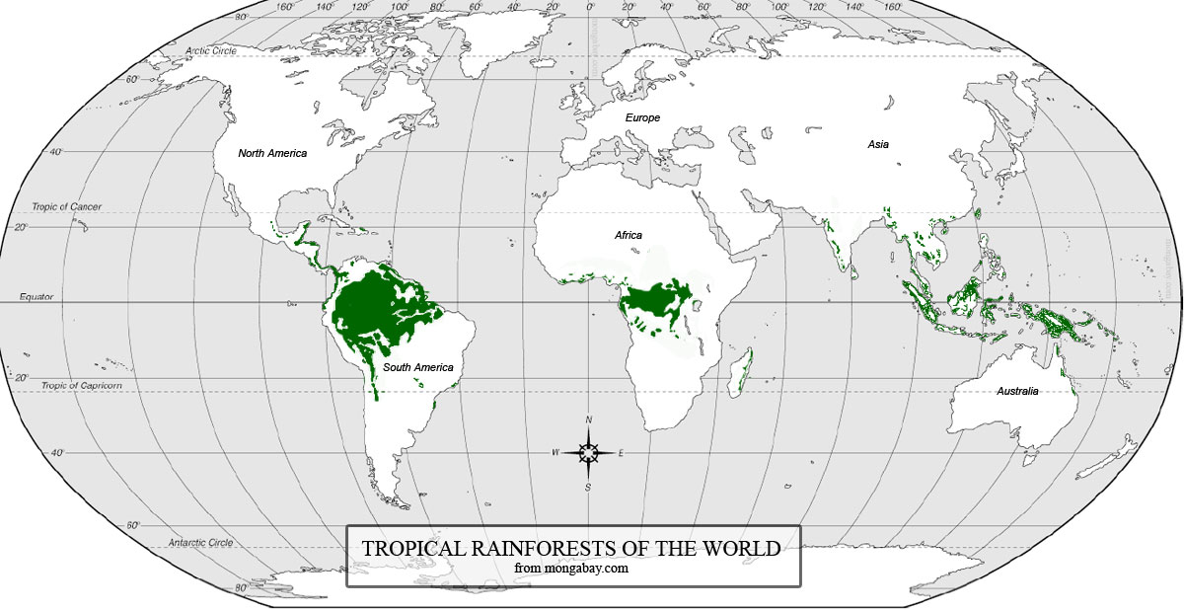
- The largest tropical rainforest is in ___________________________________________. It is called the Amazon Rainforest.
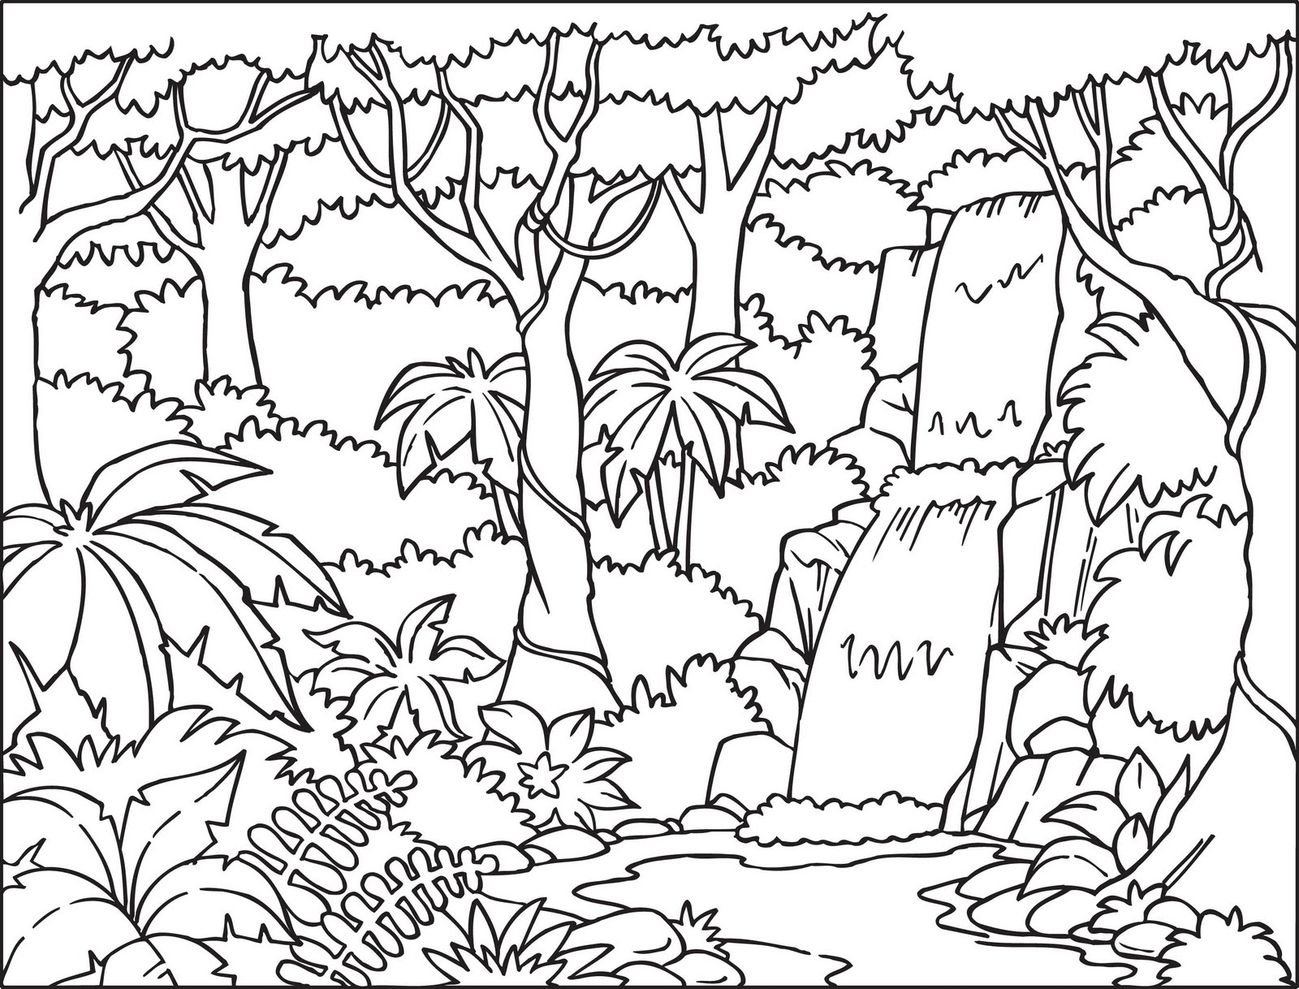

Facts about Rainforests
- Rainforests get at least ______ inches of rain a year.
- The temperature is usually between 75-80 degrees.
- Tropical Rainforests cover about _____ percent of the Earth’s surface and are VERY important to the Earth’s ecosystem.
- The rainforest trees remove carbon dioxide from the air and produce ______________.
- There are people who live in the rainforests. They are known as indigenous people.
- Many of our foods/herbs come from the rainforest.
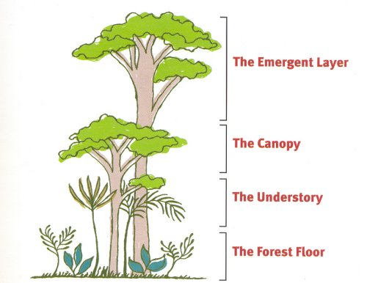

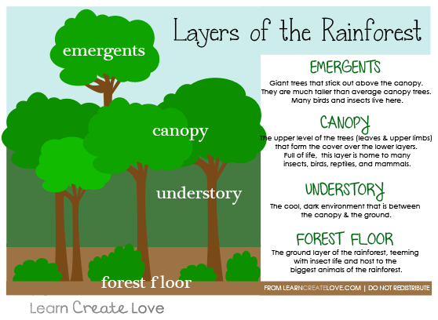

The Understory
The understory is the second
layer from the bottom. This layer
has some plants, but it does not
get as much sunlight because of
the coverage from the canopy.

List some animals that can be
Found in the understory layer.
______________________________
______________________________
______________________________
______________________________
______________________________

Draw an animal that lives in the understory.

The Forest Floor
The forest floor is the bottom
layer of the rainforest. It is home
to many bugs, insects, and
decomposers. The largest
animals live here. There is not
as much plant life because of
the shade.

List some animals that can be
Found on the forest floor.
______________________________
______________________________
______________________________
______________________________
______________________________
Draw an animal that lives on the forest floor.

