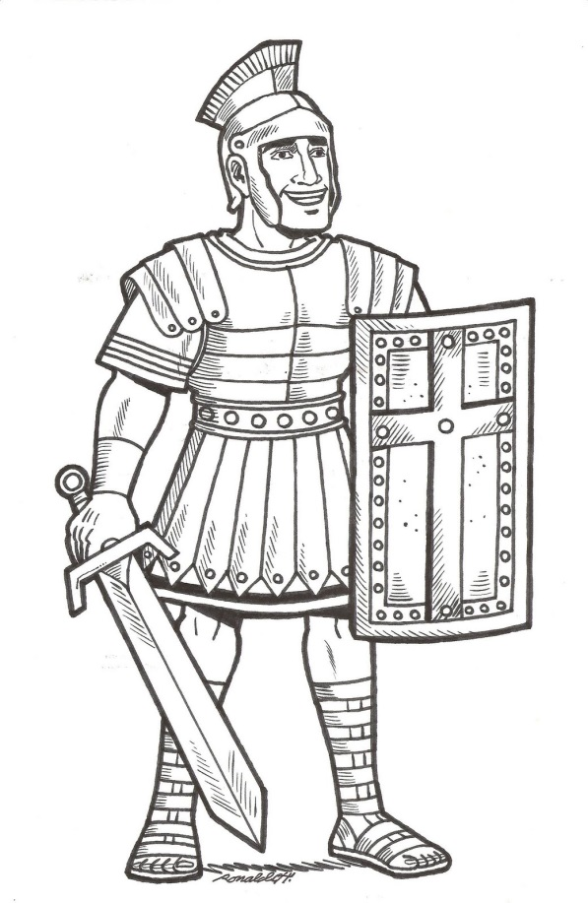
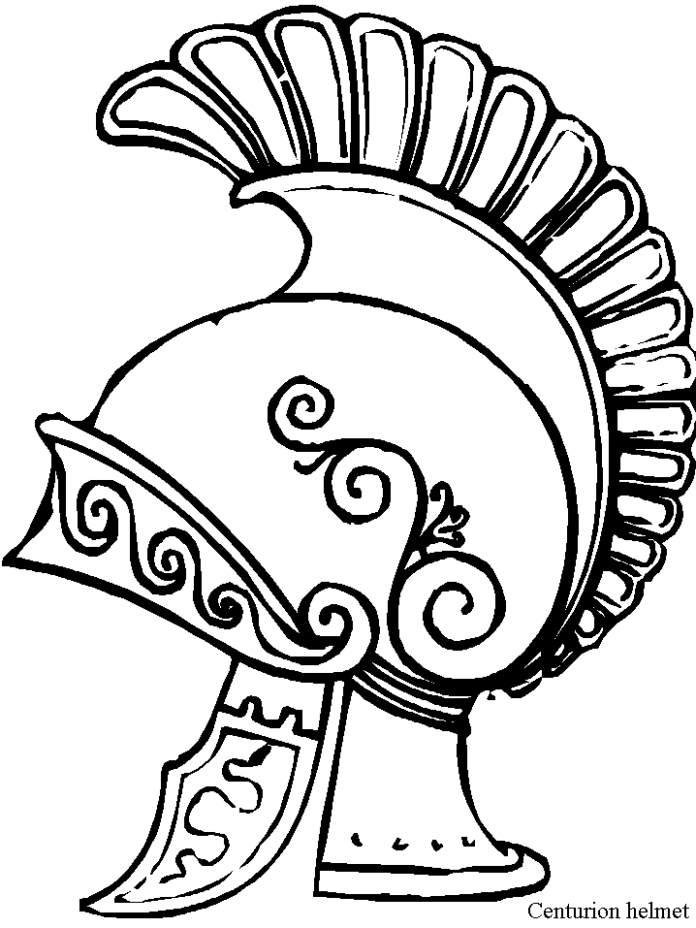
ANCIENT ROME

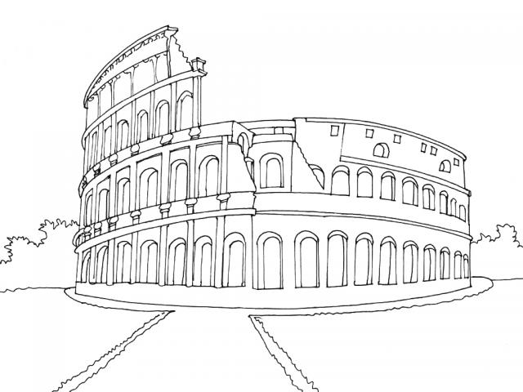

NAME ____________________________________________________________________________________________________
Important Vocabulary

- Contribution- the act of giving or doing something
- Direct democracy- a government in which people vote to make their own rules and laws
- Representative democracy- a government in which the people vote for (elect) a smaller group of citizens to make the rules and laws for everyone
- Characteristics- different traits
- Natural Resources- materials that come directly from nature (ex. Water, soil, wood, coal)
- Human Resource- people working to produce goods and services
- Capital Resources- goods made by people and used to produce other goods and services (ex. Machines, tools, buildings)
- Producers- people who use resources to make goods and/or services
- Goods- things that people make or use to satisfy needs and wants
- Services- activities that people pay money for to make their lives easier

Ancient Rome and Greece were both located on land near the Mediterranean Sea. Ancient Rome is also located near the Tiber River. Rome was built on many __________________. Rome had limited ____________________________________.

PHYSICAL CHARACTERISTICS
Rome is located on the Italian Peninsula on the continent of ____________________. The peninsula looks like a long, high-heeled ____________. About halfway up the peninsula is the __________________________________. This is where the Ancient Romans built their city. Like Greece, Rome is a land of _________________________ with seas on 3 sides. The soil would allow for crops such as ______________, _______________, and _______________ to be grown there.
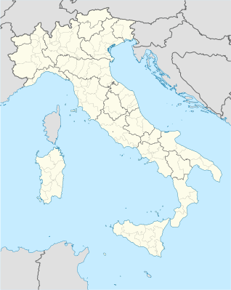

Resources
Ancient Rome was located near the Tiber River. The soil for farming was limited and there were a variety of trees that grew there. These are all examples of _________________ resources.

The people of Ancient Rome built ships, fished, made pottery, and farmed. The people worked to create these goods and services. These are _______________________ resources.

Goods were often made by people and used to produce other goods and services. These were called ________________ resources.

Contributions of Ancient Rome
Architecture
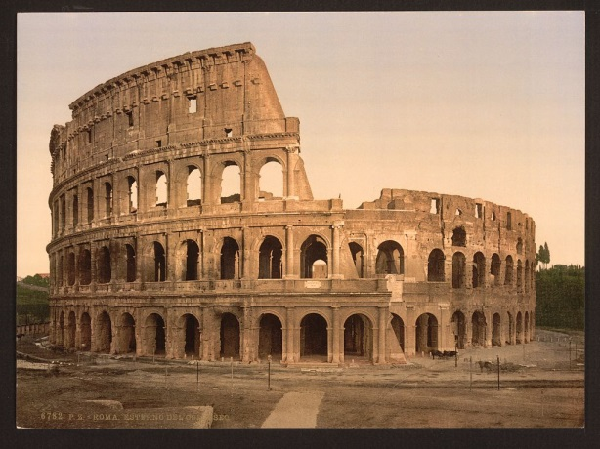
The architects of Rome used __________________ and ________________ in the construction of their buildings.

_______________________
The Coliseum was the greatest amphitheater in the empire. Thousands of people could sit and watch gladiator battle.
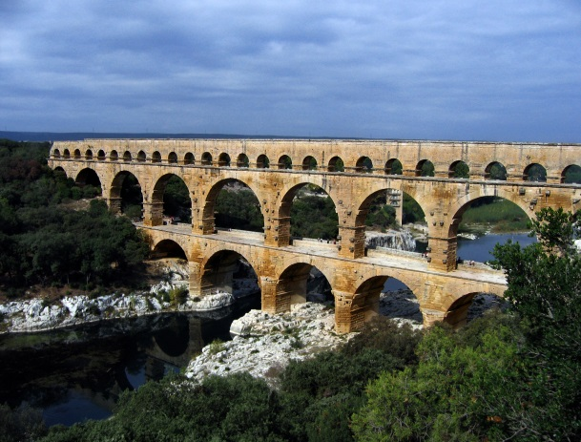

_______________________
The Romans constructed numerous aqueducts to bring water from distant sources into their cities and towns, supplying public baths, latrines, fountains and private households.
Contributions of Ancient Rome
Government
The Romans used a ___________________________ democracy. Citizens would __________ for leaders to represent them and speak for them. In the Roman _________________, only free men were citizens. In the USA, all citizens _____ and older can vote.

The two main leaders were called the _____________. They led the armies, served as judges, and made decisions for the citizens of Rome. Wealthy men known as ___________________ advised the consuls.

