NAME________________________________________________________
Ancient Rome Study Guide
Please study this guide, your notes on Ancient Rome including important vocabulary, your Venn Diagram, and your cut and paste sort. There is also a Powerpoint and review games on my webpage that you can use to study.

Geography & Physical Characteristics
- Rome was located on the ___________________ ___________________.
- What continent was Rome located on? _______________________
- What body of water did Ancient Rome and Greece both use? _________________________________________________________
- Rome was built on _______________ and had limited _______________________________.
- Rome’s land was ________________ rocky than the land in Greece.
- The Italian Peninsula looks like a long, high-heeled _____________.
- What main crops did they grow in Rome? __________________________________________________________________

Human Characteristics (Jobs)
- What human characteristic (job) would have helped the Romans get the things they needed but didn’t have? _____________________
- One main job in Rome was ________ builders. They built the roads so that the __________________ could travel more quickly.
- Who grew the crops in Ancient Rome? _________________________
These same people built ___________________ into the hillsides.
- How are the human characterisitcs of Rome and Greece the SAME?
_____________________________________________________________________
- How are the human characterisitcs of Rome and Greece DIFFERENT? __________________________________________________________
_____________________________________________________________________

Resources
- When goods are made by people and used to produce OTHER goods and services, these are called ________________ resources.
- Rome was located near the ________________ River. The river, soil, and trees are all examples of ___________________ resources.
- The people of Rome worked to build roads, make pottery, and grow crops. These are all examples of ____________________ resources.

Architecture
- The architects in Rome and Greece used ________________ and ________________ in the construction of their buildings.
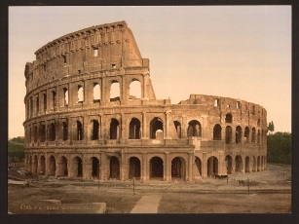
This building is called the ______________________.
This is where people could watch _______________
battles.

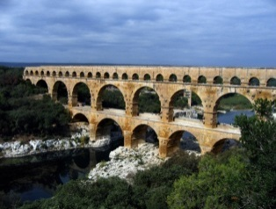
These are called _____________________________.
This is how Rome got its water supply. The main
Feature in these are _______________.

Government
- The Roman government used a ______________________________ democracy.
- Wealthy men known as ________________________ advised the consuls.
- Citizens would ______________ for leaders to represent them and speak for them.
- The two main leaders were called ________________.

