Spelling List March 10-14: Test Friday
Dogzilla
Lesson 19
This is your child’s Spelling List for the week. The choices change weekly. Your child is expected to complete FOUR assignments by Friday. Each assignment can only be completed ONCE. No Duplicates will be given credit. These are checked for a grade.

- mood
- wooden
- drew
- smooth
- blue
- balloon
- true
- crooked
- chew
- tooth
- hooves
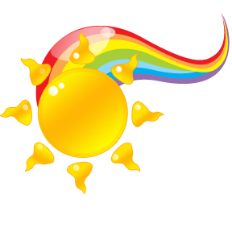
- cool
- food
- pooch
- blew
- foot
- loose
Write each spelling word once and write a synonym and an antonym for each | Write your words 2 times each. Write the vowels (a,e,I,o,u) in one color and the consonants (all other letters) in a different color.  *in print | Write a good quality sentence with each word.  *in Print
Write your words 3 times each  *In cursive | Practice Spelling Test  *Once in print, once in cursive- Have an adult sign the top | Complete assignments/ games on Spelling City
- jewel
- dictionary
- encyclopedia

