The Water Cycle
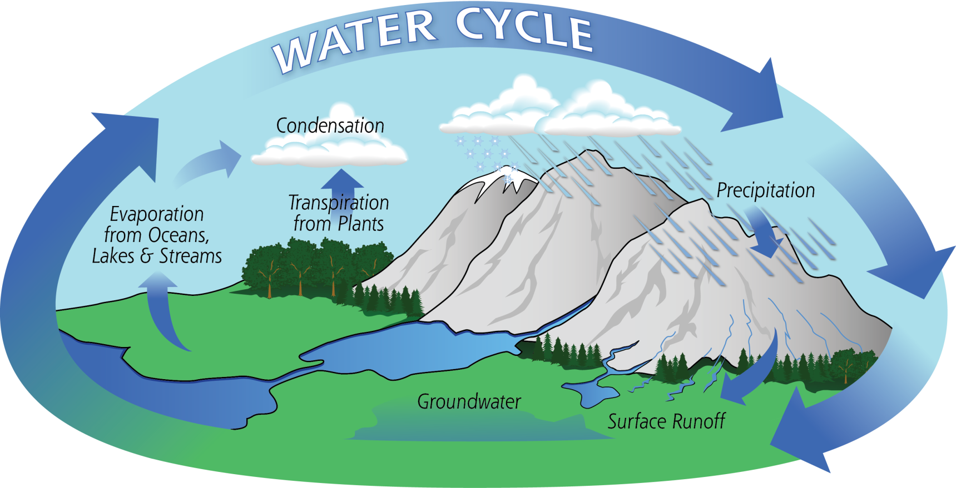

Name_________________________
Important Vocabulary
- Water Cycle- the never-ending path water takes between Earth and the atmosphere
- Evaporation-the changing of a liquid to a gas
- Water Vapor- water in the form of a gas
- Condensation- the changing of a gas into a liquid
- Precipitation-water that returns to Earth as rain, snow, sleet, or hail
- Collection- where water is held after it falls from the atmosphere (oceans, rivers, creeks, etc)

Water Cycle Facts
- The water cycle is the ____________________ of water from the ground to the ________ and back to the ground by evaporation, condensation, and precipitation.
- The energy that drives the water cycle comes from the _________.
- Our water supply on Earth is __________________. Pollution reduces the amount of usable water. We have to _________________ of limited water supply.
- Water is a simple compound essential for _________ on Earth. Living cells are made mostly of ___________.

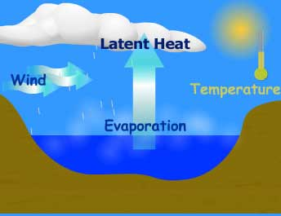
Evaporation

Evaporation is when the _______ heats up water in rivers, lakes, or oceans and turns it into ____________ or steam. The water vapor leaves the river, lake, or ocean and goes into the air. When your parents boil water on the stove, the steam you see is evaporation!

Evaporation: when liquid water is heated and changed to a gas
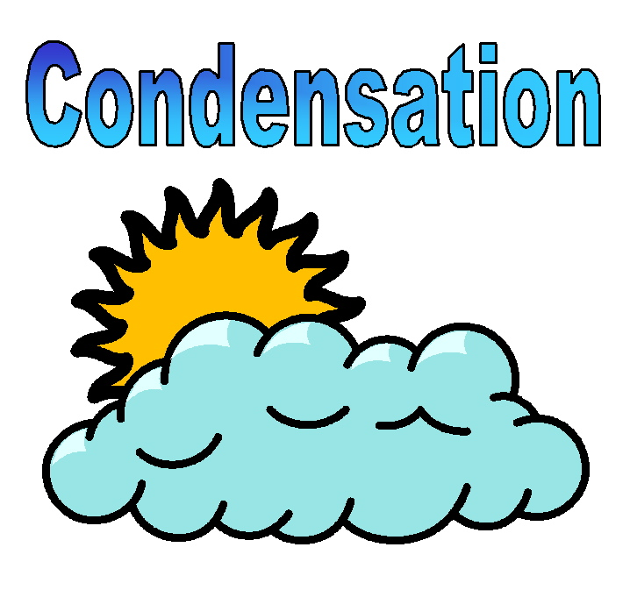

Water vapor in the air gets ____________ and changes to a ______________ which forms CLOUDS.
When you have a cold drink and water droplets form on the outside, that is condensation!
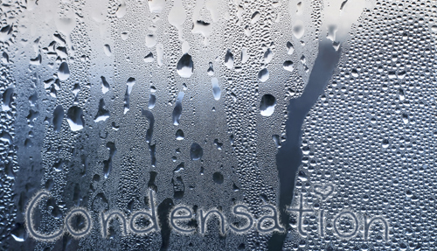

Condensation: when water vapor gets cold and changes into a liquid
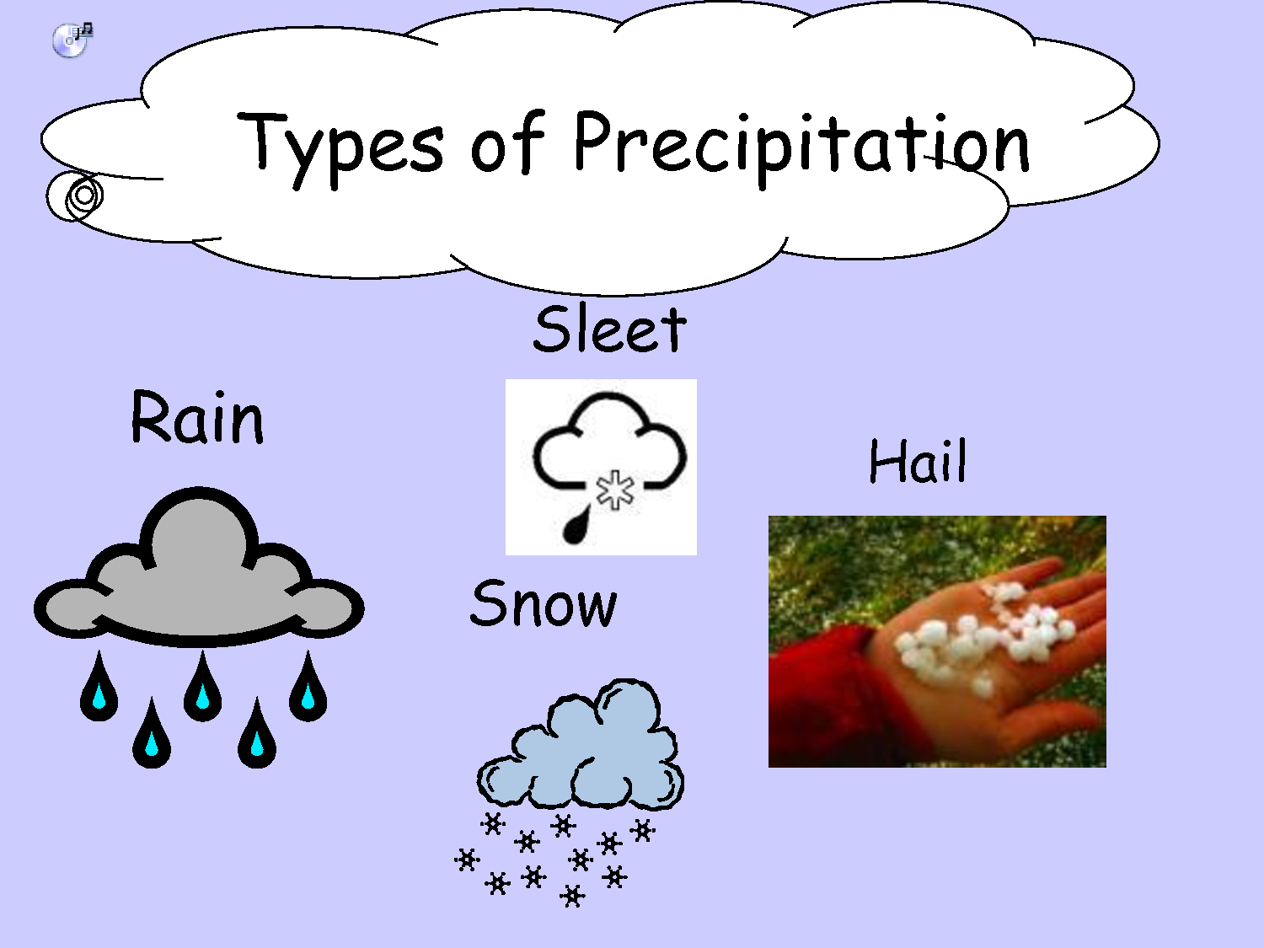
Precipitation

Precipitation occurs when so much ____________ has condensed that the air cannot hold it anymore. The clouds get _____________ and water falls back to the Earth in the form of rain, snow, sleet, or hail.
Precipitation: water as a liquid or a solid falls to the ground
Major Water Sources
- _____________________________
- _____________________________
- _____________________________
Local Water Sources
- New River
- Claytor Lake
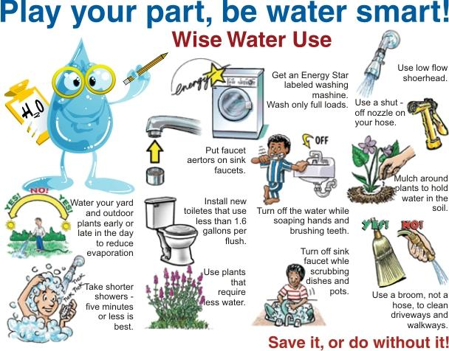

Possible Water Pollution
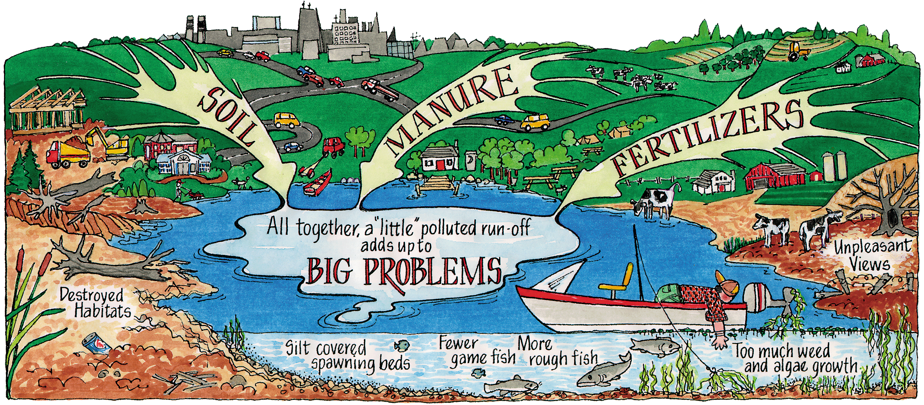
Runoff

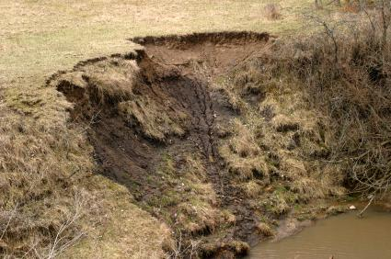
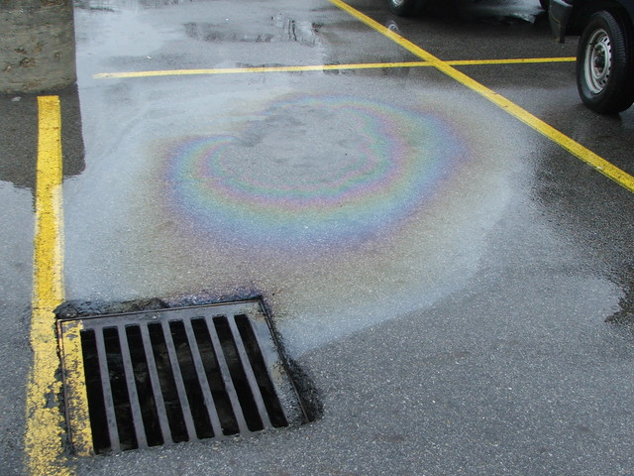
Oil in Parking Lots Eroding Soil

